**Python Programming Language**

**Assignment # 1**

**Solved**

**1. Write a Python program to print the following string in a specific format (see the output).**

Twinkle, twinkle, little star,

How I wonder what you are!

Up above the world so high,

Like a diamond in the sky.

Twinkle, twinkle, little star,

How I wonder what you are

**Code & Output:**

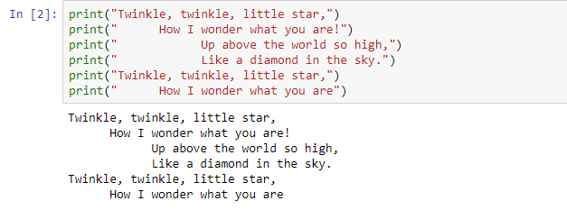

**2. Write a Python program to get the Python version you are using.**

**Code & Output:**

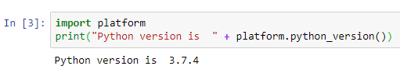

**3. Write a Python program to display the current date and time.**

**Code & Output:**

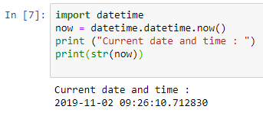

**4. Write a Python program which accepts the radius of a circle from the user and compute the area.**

**Code & Output:**

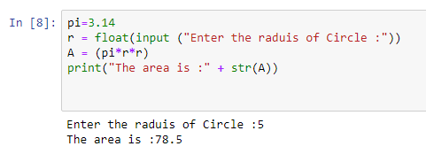

**5. Write a Python program which accepts the user's first and last name and print them in reverse order with a space between them.**

**Code & Output:**

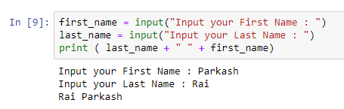

**6. Write a python program which takes two inputs from user and print them addition.**

**Code & Output:**

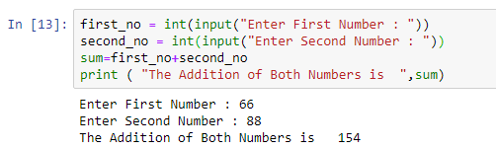

**SUBMITTD BY**

**NAME: PARKASH RAI**

**EMAIL: parkashrai560@gmail.com**